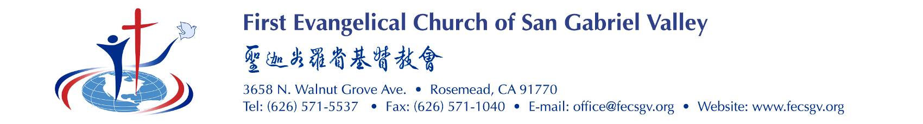

Short Term Mission Reflection Form

STM Applicant(s):
STM Name:
STM date (when to when): | MM/DD/YY to MM/DD/YY
STM Location(s):

Please use these questions as a guideline to help you to share your reflections. You are free to share your thoughts in different format. The essence is to see what God has done in your life through this trip.
- What were your goals for this trip?
- Please share how did you achieve the goals stated above? If you did not achieve some of the goals set, please share what obstacle(s) that prevents you achieving them.
- Please share your spiritual journey for this trip? How does God talk to you throughout this trip?
- What did you learn about the people group you served?
- Words of thought you would like to share with us, such as your lesson learnt, area that you need to improve, etc.

參與短宣者姓名
短宣名稱
短宣期間 | 由 日/月 /年 至 日/ 月 /年 （開始和結束日期）
短宣地點

請利用下列的指引問題幫助你分享短宣的感想。 你可採用任何形式作答，主要的目的是審察神在這次短宣在你身上的作為。

- 甚麼是這次短宣要達成的目標？
- 請分享你如何達成上述的目標？若你未能如願達成部份所定的目標，請分享甚麼原因攔阻你不能達成目標。
- 請分享在這次短宣你的靈命經歷，神在短宣中怎樣對你說話？
- 在你所事奉服務的團體中你學到些甚麼？
- 分享你一般的感想，如學到的功課、有甚麼地方你自己需要改進‧‧‧等等

